CHAPTER THREE

SYSTEM ANALYSIS AND DESIGN

3.1 INTRODUCTION

This chapter explains the method used in carrying out this project in section 3.1. Section 3.2 presents the problems with the existing system with a view to proposing a new system in section 3.3. The architecture of the proposed system in terms of system model, flowcharts, class diagrams, use case diagrams and database structure are presented in sections 3.4 – 3.5. Section 3.6 presents the network architecture for the system and section 3.7 shows the choice of programming language.

3.2 METHODOLOGY

Information necessary for the development of the new system was gathered by means of interviews and observation. The proposed system is presented using uml diagrams and the corresponding databases are designed using mysql database while the system which comprises of two part;

The end user (informant / sender) session which is a mobile reporting app implemented using nodejs and the receiver session which is a web based application created using HTML, CSS and JavaScript.

3.3

PROBLEMS OF THE EXISTING SYSTEM

Here In Nigeria, The commonly or widely used medium and method of contacting or alerting the fire service via phone calls which is inefficient considering the following factors;

Cost: money spent on airtime calling fire service.

Time: time is wasted on trying to reach fire service via phone calls because informants of fire accidents will have to give detailed description and narration of incident as a proof which wastes a whole lot of time.

Proofs: this existing medium of informing the fire service is limited when it comes to concrete or visual evidence of incident which will to a very good extent encourages prank calls.

Location: this problem is mostly faced by fire service response teams as they are not so sure of location of incident

3.3.1 Limitations of the Existing System

Due to the conventional means of contacting fire service, certain limitations have been posed on notifying or reporting to fire service and getting quick response in shortest time possible.

1. Limited to voice data: limited ability to get detailed information as phone calls only give narrated information without any features to give proofs if such incidents really exists or not i.e too much narrations of incidence without details.
2. Ambiguity in data given/lack of facts: during fire accidents, reporters might not be in a good state of mind and might give unclear information about incident as reporters has a high chance of been tensed at situations like fire accidents i.e. information are often vague and sometimes misleading to fire service personnel.
3. Cost of making report: phone calls usually are such that if enough airtime is not available, the reporting process is likely to terminate as its no news that cost of voice calls are on the high side.
   1. DESIGN OF FIRE NOTIFICATION SYSTEM

Here is a proposal presentation to set up the fire notification or reporting system with the aim of carrying out the following operations:

1. Visual media capabilities: This feature allows for capturing fire incident scenes as visual evidence and proof of its occurrence. This is implemented by simply using smartphone cameras to take shots or short video clips and sending it to the fire service portal.
2. Geo spatial feature: this aids in telling the location of reporter relative to fire incident scenes in order to save time and cost.
3. A form: this contains reporter’s details, personal information and optionally a brief on fire incident description.

3.5 SYSTEM DESIGN

This section presents the working of the system using use case design, structure chart, class diagram and sequence diagram representation of the proposed system.

USE CASE DIAGRAM

The diagram below depicts the functionality and requirement of the system in view. As shown above the first actor which is the reporter first encounters the registration session of the mobile application in view, which leads him or her to another session where there is a menu with the report button inclusive, and finally a visual proof of trueness or correctness of event.

After the first actor is done with its reporting, the second actor (fire service) confirms information by the first actor and then closes the session at its own end after confirmation of incidence.

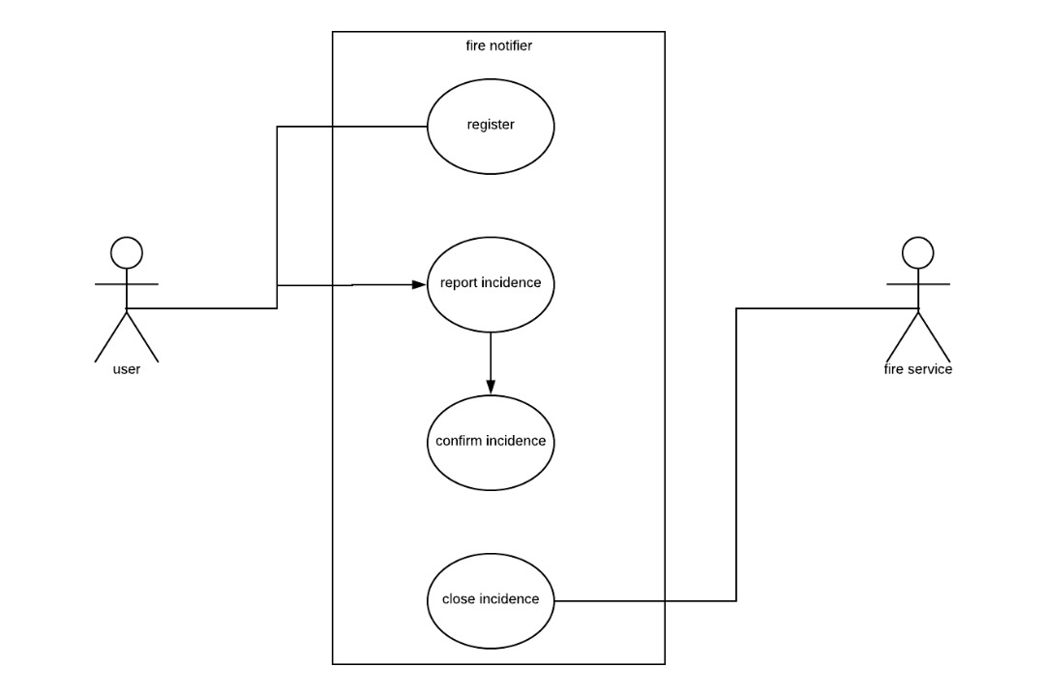

Use case diagram view of proposed fire notification and reporting system

SEQUENCE DIAGRAM

The sequence diagram below simply depicts interaction between objects in a sequential order i.e. the order in which these interactions take place.it is a more detailed step by step order of interaction between objects ranging from the reporter, to the fire service portal and everything in between. It depicts what happens from the log in interface, where the forms are filled by the reporter, how the record of reporter is created, stored and used, when geo location is gotten down to fire service portal receipt and approval or validation of report.

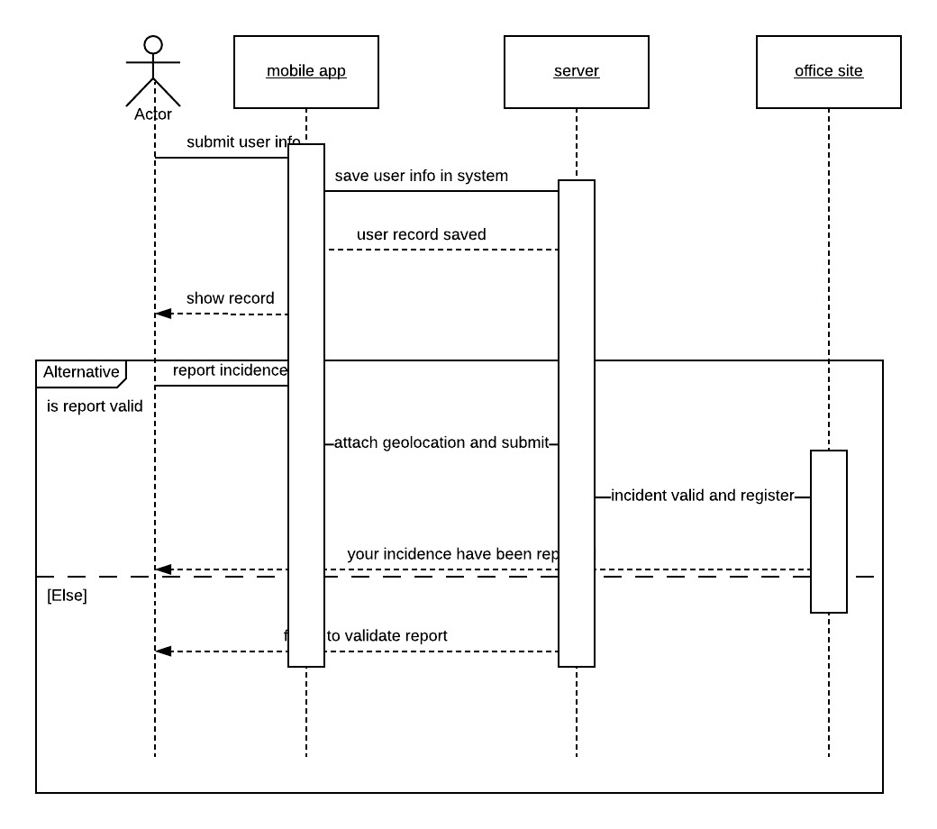

**sequence diagram of the fire notification system**

**SYSTEM MODEL DESIGN**

The diagram below shows the system model design for the fire service portal.

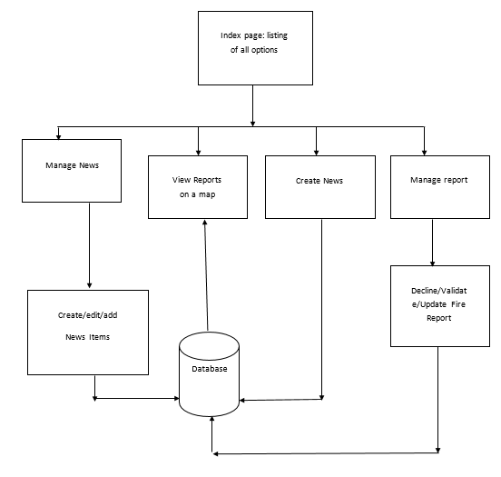

System Model Design for the Office Portal

**ENTITY RELATIONSHIP DIAGRAM**

The above diagram shows the communication in database between the user and the fire service portal

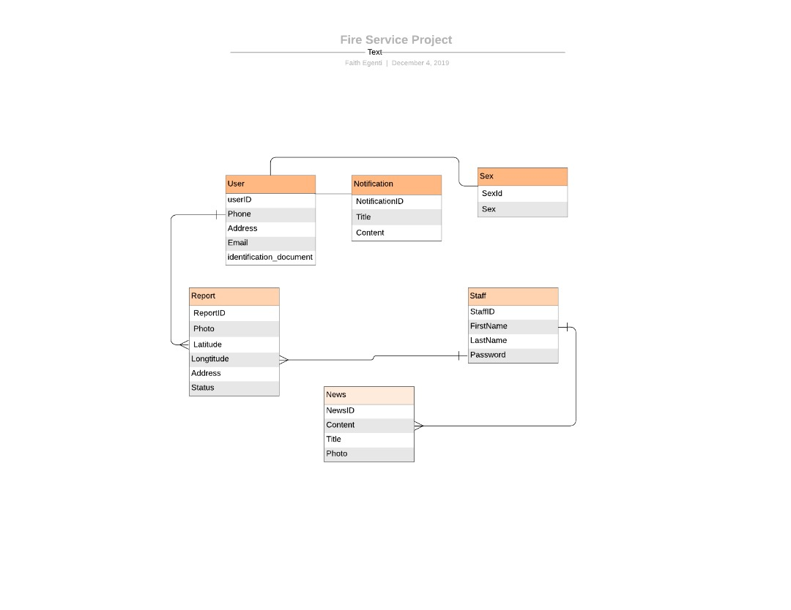

* 1. Database Design

The most important step in information processing is input process and output process, between both is the storage. Data can be store to be processed later on the output from processes of input data can be stored for later use. Invariably, it is necessary at this stage to design various files‘ that will be used by programs for data storage.

The design of file‘s includes:

* The definition of data and length of record‘s field
* The index key(s) of each file, if any

The file name used for this new system is FIRE SERVICE and it comprises of.

TABLES with the following filename‘s:-

* Users
* Report
* Staff
* News
* Notification

TABLE 3.1: Users Table

This table below consists of information about the external users who would be making a report

|  |  |  |  |
| --- | --- | --- | --- |
| Field Name | Data Type | Field Size | Constraints |
|  |  |  |  |
| UserID | Integer | 14 | Primary key |
|  |  |  |  |
| Photo | Image | Max | Nullable |
|  |  |  |  |
| FirstName | Varchar | 20 |  |
|  |  |  | Not nullable |
| LastName | Varchar | 20 | Not nullable |
|  |  |  |  |
| Address | Varchar | 100 |  |
|  |  |  | Not nullable |
| Identification_Number | Varchar | 50 | Unique |
|  |  |  |  |
| Sex | Integer | 1 | Foreign Key |
|  |  |  |  |
| Phone | Varchar | 11 | Unique |
|  |  |  |  |
| Password | Varchar | 50 | Not null |
| Identification_document | Image | Max | Nullable |
|  |  |  |  |

This table consists of the necessary information that helps to identify the user who is using the app and makes him accountable for all fire reports logged by his app. This is as to reduce the instances of prank calls.

TABLE 3.2 Report Table

This table below consists of information about the report being make and to manage the full report life cycle.

|  |  |  |  |  |
| --- | --- | --- | --- | --- |
| Field Name | Data Type |  | Field Size | Constraint |
|  |  |  |  |  |
| ReportID | integer |  | 14 | Primary key |
|  |  |  |  |  |
| Picture | image |  | Max | Not null |
|  |  |  |  |  |
| Address | varchar |  | 100 | Not null |
|  |  |  |  |  |
| Name | varchar |  | 40 | Not null |
|  |  |  |  |  |
| UserId | integer |  | 14 |  |
|  |  |  |  | Foreign Key |
| Latitude | Decimal |  | 10,4 |  |
|  |  |  |  | Not null |
| longitude | Decimal |  | 10,4 | Not null |
|  |  |  |  |  |
| ReportedDate | DateTime |  | - | CurrentTimeStamp |
| ResolvedDate | DateTime |  | _ | Nullable |
| status | tinyInt |  | 1 | Default : 0 |
|  |  |  |  |  |

This table consist of the fields needed to manage the full life cycle of a report. It would have a one to many relationship with the table users because 1 user would be able to make multiple report. The mandatory fields such as address, latitude and longitude and picture has to be supplied for a report to be successfully filed.

TABLE 3.3 Staff Table

This table below consists of information about the fire service IT staff whose job is to manage the system and respond to calls.

|  |  |  |  |
| --- | --- | --- | --- |
| Field Name | Data Type | Field Size | Constraint |
|  |  |  |  |
| StaffID | integer | 14 |  |
|  |  |  | Primary key |
| StaffNumber | varchar | 20 | Unique |
| Sex | integer | 1 | Foreign Key |
| Password | varchar | 50 | Masked |
|  |  |  |  |

TABLE 3.4 News Table

This table below consists of information necessary to create a information cradle where the users can get first hand fire incidence information in a very friendly news like manner.

|  |  |  |  |
| --- | --- | --- | --- |
| Field Name | Data Type | Field Size | Constraints |
|  |  |  |  |
| NewsId | integer | 14 | Primary key |
|  |  |  |  |
| Title | varchar | 100 | Not Null |
| Content | Text | 5000 | Not Null |
| CreatedDate | DateTime | - | Current Timestamp |
| Photo | image | max | Not Null |
|  |  |  |  |

TABLE 3.4 Notification Table

A notification is an instant communication from the fire service to the users, it helps to send instant messages to inform the users for possible fire hazards around their location.

|  |  |  |  |
| --- | --- | --- | --- |
| Field Name | Data Type | Field Size | Constraints |
|  |  |  |  |
| NotificationId | integer | 14 | Primary key |
|  |  |  |  |
| Title | varchar | 100 | Not Null |
| Content | Text | 5000 | Not Null |
| CreatedDate | DateTime | - | Current Timestamp |